**[The Versatile Blogger Award](http://writerschecklist.blogspot.com/2011/05/versatile-blogger-award-woot.html) – Woo Hoo!**

[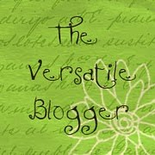](http://4.bp.blogspot.com/-RcVUByEHyd0/TcZxfneV4JI/AAAAAAAAATM/x4e1GEDJaXM/s1600/Versatile_blogger_award%5B1%5D.jpg)  
Many thanks to Mo Northam, [www.abcwriterschecklist.co.uk](http://www.abcwriterschecklist.co.uk) for passing the baton to me for, The Versatile Blogger Award – a truly wonderful surprise that came to me, like all good things seem to, on a Monday morning!

But it seems there is a price to be paid: I have to reveal 7 seven things about myself that you probably don’t know.